Database Systems Assignment (Lab 12)

Name = Poorab Gangwani

Class = 4B1

Roll-Number = CS191092

1. Write a procedure to display the name, designation, and salary of the highest paid employee. Use a subquery to get the highest paid employee.

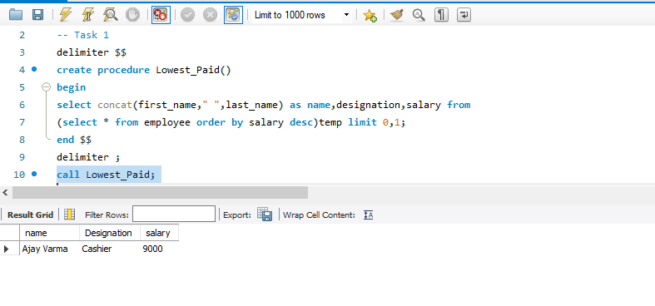

2. Write a procedure to display the details of all the employees whose salary is less than the salary specified as input to the procedure.

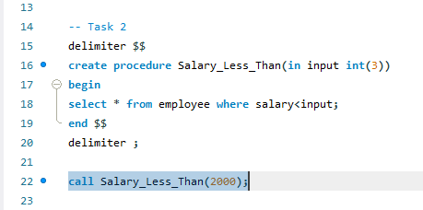

3. Write a procedure that gives the minimum of the average salaries of all the departments. The average salary should be returned in a variable that is accessible outside the procedure.

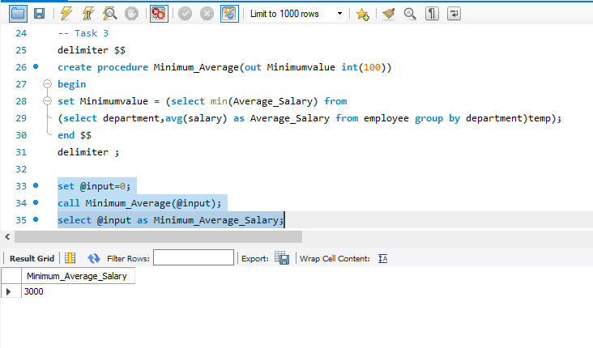

4. Create a procedure that takes employee ID as input and returns the bonus percentage for the employee as output using the following criteria: Salary more than 60% of maximum salary — 10% bonus Salary more than 40% but less than/equal to 70% of maximum salary — 20% bonus Salary more than 20% but less than/equal to 50% of maximum salary — 30% bonus Salary less than or equal to 20% of maximum salary — 40% bonus [Hint: Use if statements]

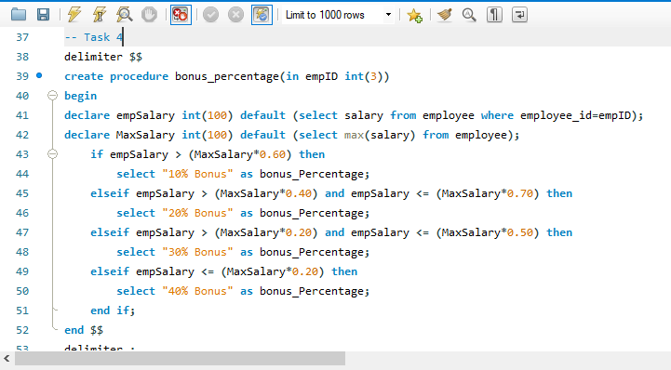

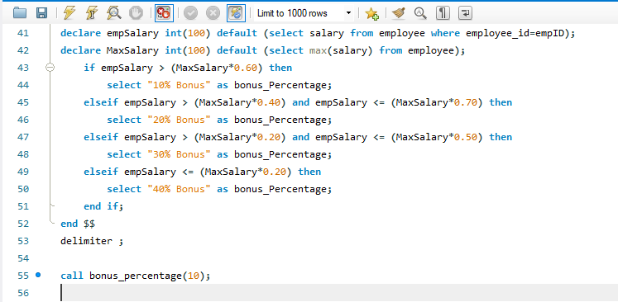

5. Modify your procedure to include a loop that performs the above task for all the employees automatically.

